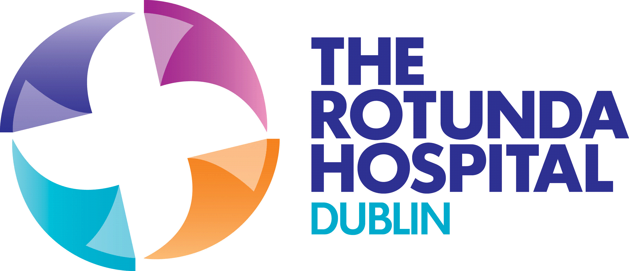 | 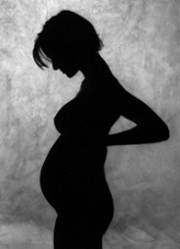  The  MAMMI  Study | Trinity College Dublin

Newsletter Issue 2, May 2014

Thank You!
Sincere thanks to all of you who have taken part in the MAMMI study so far. MAMMI is now entering its third year and over 1,500 women are now participating. The study could not take place without your ongoing support, so please keep in touch with us and let us know if your contact details change.
We love getting the photos of your babies, thank you. We were thinking of having a photo gallery on the website called ‘I was born during the MAMMI study’ and would love to know what you think about this. The gallery would include a picture of your baby, your baby’s first name but not your family name or any other personal details so that you cannot be identified. If you like this idea and would like your baby’s picture added to the gallery, please email us at contact@mammi.ie. We will only do this with your consent.

Progress to Date (April 2014)
The number of women who have completed each stage of the study is as follows:
Survey 1 (early pregnancy) 1,537
Survey 2 (3 months postpartum) 825
Survey 3 (6 months postpartum) 591
Survey 4 (9 months postpartum) 401
Survey 5 (12 months postpartum) 250
Later surveys come in as women continue in the study. We love getting your postnatal surveys as they tell us how you are getting on in your life as a new mother.
New MAMMI Study Sites
So far, all the women included in this study have had one thing in common: they have all given birth at the Rotunda Maternity Hospital in Dublin. Now, the MAMMI study is extending to include other maternity hospitals in Ireland. The MAMMI 2 study started in University College Hospital, Galway and recruitment of women began in November 2013. The research team also hope to start recruiting women from the Coombe Women & Infants University Hospital in Dublin by September 2014.

The MAMMI Study Team
Professor Cecily Begley & Professor Mike Clarke (Principal Investigators)
Deirdre Daly, a midwife and PhD candidate exploring urinary incontinence (leaking urine)
Deirdre O’Malley, a midwife and PhD candidate exploring women’s sexual health after birth
Margaret Carroll, Assistant Professor in Midwifery is leading the MAMMI 2 study in Galway
Francesca Wuytack, a chiropractor and PhD candidate investigating lower back and pelvic girdle pain during and after pregnancy
Sunita Panda, a midwife and PhD candidate investigating aspects of emergency caesarean section in first-time mothers
Jamile Marchi, a nutritionist and PhD candidate exploring maternal weight gain, diet and eating habits
Louise Rafferty, a midwife and MSc candidate examining mental health issues after birth
Susan Hannon is a research assistant and Marianne Hennessy, a postgraduate social research student, is on a 2-month work placement with the MAMMI team

Sharing the Findings
A number of our research team presented early findings from the MAMMI study at an EU Networking conference called Optimising Childbirth Across Europe. Three members of our team spoke to an audience of nurses, midwives, doctors and epidemiologists from all over Europe. These presentations were warmly received and are now available on the MAMMI website. More presentations are planned at the International Confederation of Midwives Congress which takes place in Prague this year.

Thanks also to all the staff in each of the study sites for their ongoing enthusiasm and support!

